You are a hiker preparing for an upcoming hike. You are given heights, a 2D array of size rows x columns, where heights[row][col] represents the height of cell (row, col). You are situated in the top-left cell, (0, 0), and you hope to travel to the bottom-right cell, (rows-1, columns-1) (i.e., **0-indexed**). You can move **up**, **down**, **left**, or **right**, and you wish to find a route that requires the minimum **effort**.

A route's **effort** is the **maximum absolute difference**in heights between two consecutive cells of the route.

Return *the minimum****effort****required to travel from the top-left cell to the bottom-right cell.*

**Example 1:**

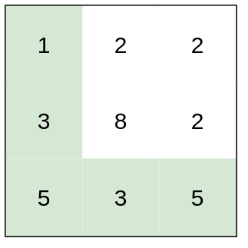

**Input:** heights = [[1,2,2],[3,8,2],[5,3,5]]

**Output:** 2

**Explanation:** The route of [1,3,5,3,5] has a maximum absolute difference of 2 in consecutive cells.

This is better than the route of [1,2,2,2,5], where the maximum absolute difference is 3.

**Example 2:**

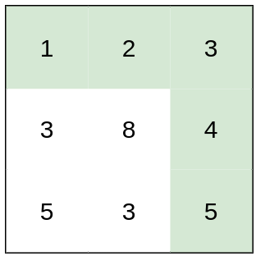

**Input:** heights = [[1,2,3],[3,8,4],[5,3,5]]

**Output:** 1

**Explanation:** The route of [1,2,3,4,5] has a maximum absolute difference of 1 in consecutive cells, which is better than route [1,3,5,3,5].

**Example 3:**

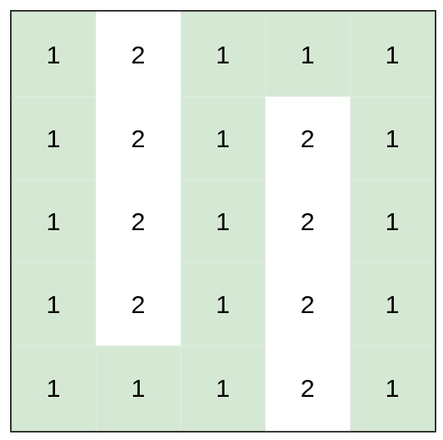

**Input:** heights = [[1,2,1,1,1],[1,2,1,2,1],[1,2,1,2,1],[1,2,1,2,1],[1,1,1,2,1]]

**Output:** 0

**Explanation:** This route does not require any effort.

**Constraints:**

* rows == heights.length
* columns == heights[i].length
* 1 <= rows, columns <= 100
* 1 <= heights[i][j] <= 106